4.10 Antiderivatives Worksheet

- Find the most general antiderivative for each of the following. Use algebra to help simplify before trying to find antiderivatives when appropriate.

- Find given that .

We can see that and we were told that .
Therefore we can say that and so

We can then see that and we were told that .

Therefore we can say that

So we have that .

- The acceleration due to gravity near the surface of some planet is . An object is shot upward from the surface of this planet and 4 seconds later it has fallen back to the surface. What is the initial velocity of this object (be sure to include units in your answer)?

We want to find the initial velocity of the object, which .
We know that .
We calculate that:

We know that so which implies that

We know that so

Therefore , which means that .

We want to find the initial velocity of the object, which is .

- A particle moves in a straight line and has acceleration given by . Its initial velocity is and its initial displacement is . Find its position function .

If , then .
Since we know that we can say that which implies that .

If , then .
Since we know that we can say that which implies that .

- Find f if .

We can see that and .
We know that so, which implies that

We also know that so, which implies that
.

- A ball is thrown upward with a speed of 48ft/s from the edge of a cliff 432ft above the ground. Find its height above the ground t seconds later. When does it reach its maximum height? When does it hit the ground? (Acceleration due to gravity is -32ft/s²)

We know that and that and that .
We can see that and since we have which implies that .
We can then see that and since we have which implies that .

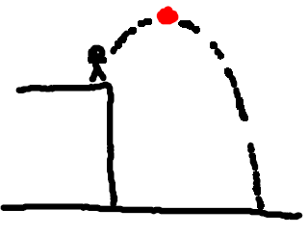
The ball reaches it maximum height when
The ball hits the ground when
The ball hits the ground at .

